CO2 ASSESSMENT TOOL 2: SCENARIO-BASED ASSESSMENT
Name: Lavanya
Reg No: 192521271
Course Name: Design And Analysis of lgorithms
Course code: CSA 0613
Linear Search in Hospital Patient Record System
Aim
To search a patient's record using the Linear Search algorithm.
Problem Statement
A hospital stores emergency patient records in an unsorted manner for quick updates. Doctors need to search for a patient's record using Linear Search.
Algorithm
- Start.
- Store patient IDs in an array.
- Read the patient ID to search.
- Compare the search ID with each array element.
- If found, display the position.
- Otherwise display "Patient Record Not Found."
Source Code:
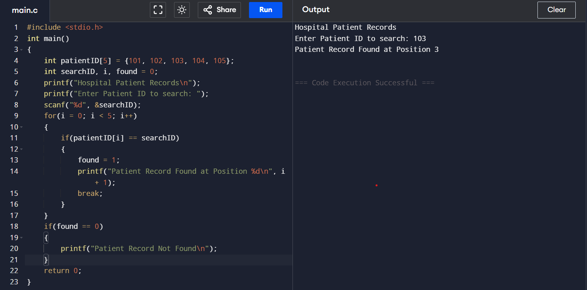\
Analysis
- Best Case: O(1)
- Average Case: O(n)
- Worst Case: O(n)
Linear Search checks each element one by one until the required patient record is found.
Documentation
- Programming Language: C
- Compiler: GCC/Code::Blocks/Dev C++
- Algorithm Used: Linear Search
- Data Structure: Array
Conclusion
Linear Search is suitable for searching unsorted emergency patient records because it does not require sorting and allows quick updates.

